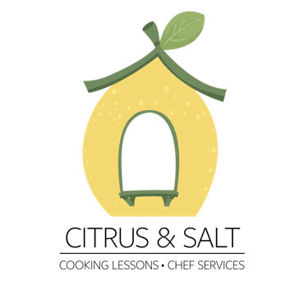

pastry Menu

Rugelach
Classic rolled pastry filled with cinnamon and sugar

sufganiyot
traditional hannukah donut filled with chocolate ganache

blintzes
eastern European sweet crepes with homemade ricotta filling

basbousa
middle eastern semolina cake with sugar syrup

*students can choose three of the four dishes above for a 3 hours class

Price list:
Individual in a group class: 240nis
Private: 500nis
Private Couple:600nis
Group of 3: 750nis
Group of 4:900nis
Group of 5+:230nis/person

